TEAM -11

# 11. Designing a Infographic Using Canva

Project Documentation:

## What is Infographic ?

An infographic is a collection of imagery,data visualization like pie charts and graps,And minimal text that gives an easy-to-understand overview of a topic.

Timeline History Infographic - 1

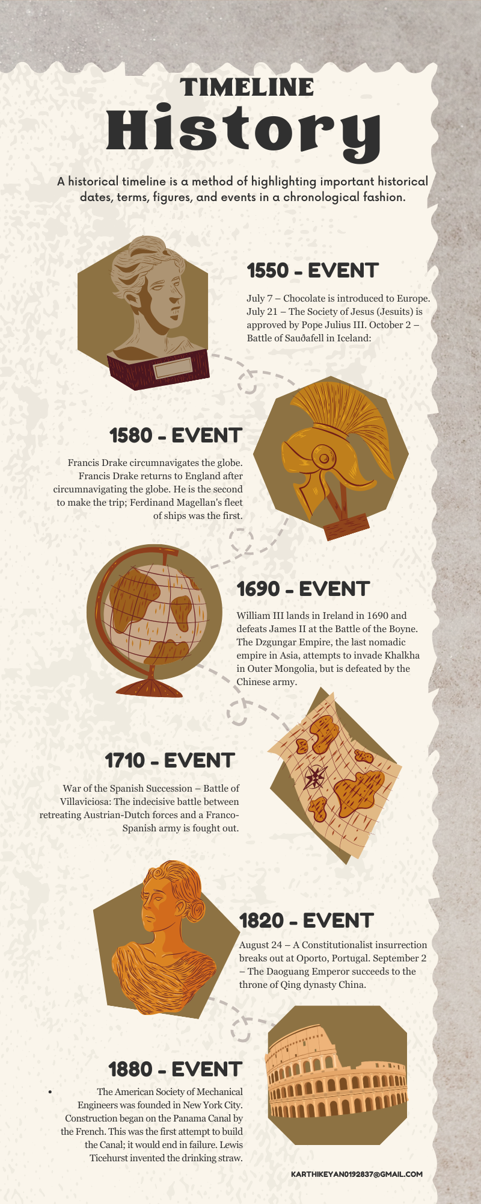

Brown Scrapbook Natural History Infographic – 2

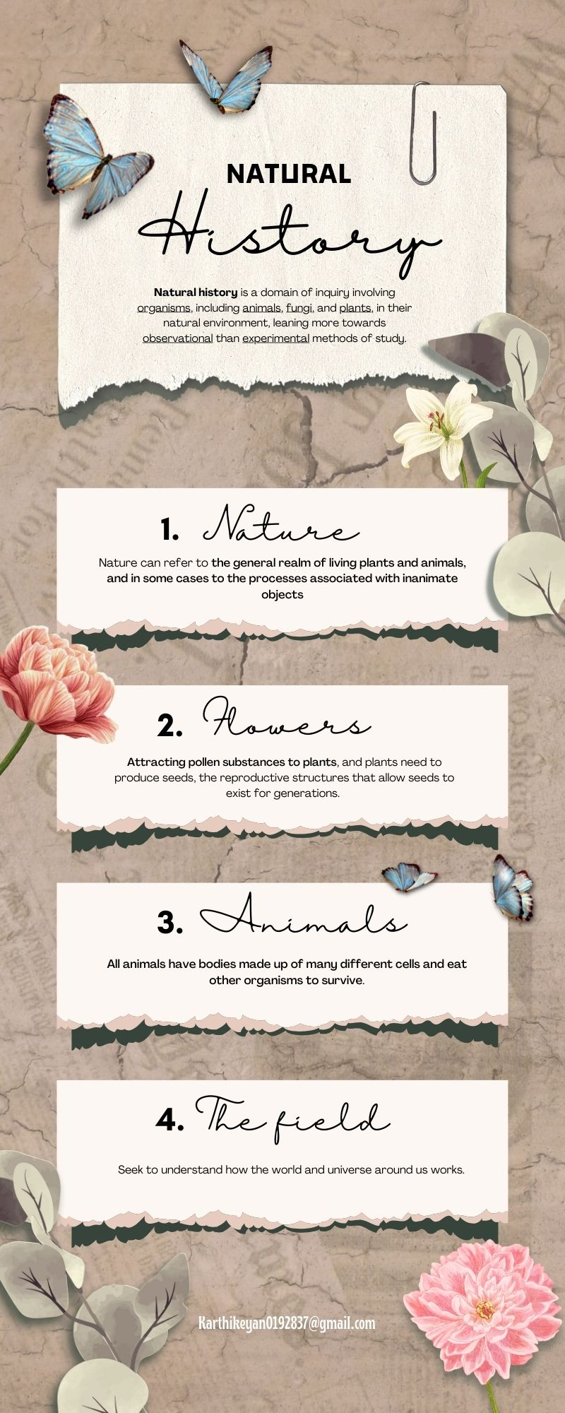

Canva Editing Key Works :

1. First, I opened the canva app on my phone,

2. I logged in my id. Canva app opens,

3. After clicking on Templates,the search bar will open,

4. The topic given to me was Infographic Design.

Which I typed in the search bar.

5. It contains more Templates. I choose one that I liked.

6. In that, I started to edit the templates called

“Timeline History”.

7. Canva app is very easy to understand editing app.

It has more than 100,000 templates to create more

Designs.

8. I opened the timeline history templates and first typed

What is timeline history.

9.For that, I typed the timeline history that I knew in

Those templates.

10 . After typing , I changed fonts and Font styles.

11. Next I went to elements and changed shapes to

Photos.

12. I changed the shapes to the photos and it gave

A nice look to my editing.

13. Canva app has many features. So I was able to give a

Better Editing.

14. Finally, My editing work is done. I will edit it

Well and develop my editing knowledge.

15. After all the work done, I did the download.

16.Let me know about this canva app ,First of all

I would like to express my thanks for the

“NAAN MUTHALVAN SCHEME”

THANK YOU

ALL

THANK YOU ALL

# 